Revit Macro Samples
1.MacroSamples_RVT
This is a C# application-level module; it contains a macro named “MacroSamples_RVT”. This sample demonstrates a possible situation of application-level macros to monitor the Revit session for certain events, such as document saving.

Please copy this folder into

%ALLUSERSPROFILE%\Autodesk\Revit\Macros\2025\
[Architecture|MEP|Structure|Revit]\AppHookup

And then open Revit_Macro_Samples.rvt and run it in macro manager dialog box.

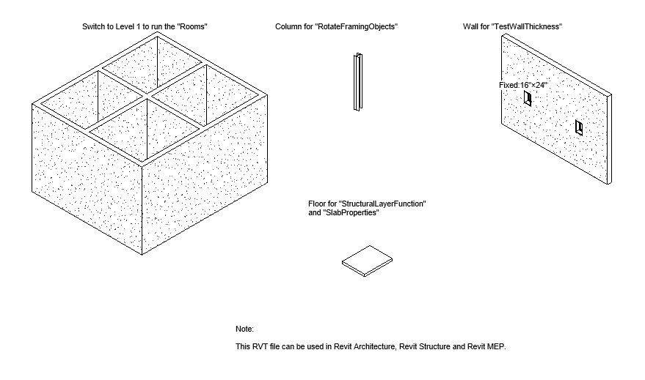
Figure 1: Revit_Macro_Samples.rvt

C# Samples:
Sample Type | Sample Macro Name | Notes
Simple Samples | QuickPrint_FloorPlans  QuickPrint_Elevations  QuickPrint_Section
Simple Samples | FindAndReplaceText
Simple Samples | CapitalizeText
Simple Samples | FindAndReplaceWinType
Simple Samples | DeleteObject
Simple Samples | ProjectInfo
Common Samples | CreateBeamsColumnsBraces
Common Samples | GridCreation
Common Samples | Rooms | Not available for Revit Structure
Common Samples | RotateFramingObjects
Common Samples | SlabProperties
Common Samples | StructuralLayerFunction
Table 1: Revit Macro Samples in C#
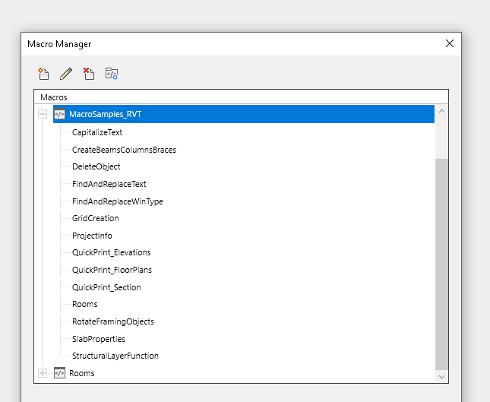
Figure 2: Revit Macro Samples in C#

- MacroSamples_MEP
This is a C# application-level module; it contains a macro named “MacroSamples_MEP”. This sample demonstrates a possible situation of application-level macros to monitor the Revit session for certain events, such as document saving.

Please copy this folder into

%ALLUSERSPROFILE%\Autodesk\Revit\Macros\2025\
[Architecture|MEP|Structure|Revit]\AppHookup

And then open Revit_Macro_MEP_Samples.rvt and run it in macro manager dialog box.

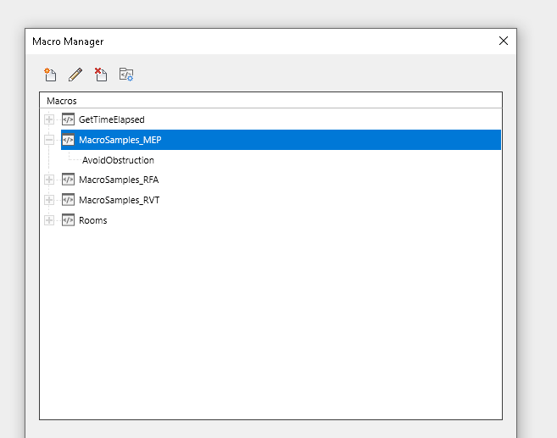
Figure 3: Revit Macro MEP Samples

- MacroSamples_RFA
This is a C# application-level module; it contains a macro named “MacroSamples_RFA”. This sample demonstrates a possible situation of application-level macros to monitor the Revit session for certain events, such as document saving.

Please copy this folder into

%ALLUSERSPROFILE%\Autodesk\Revit\Macros\2025\
[Architecture|MEP|Structure|Revit]\AppHookup

And then run it in macro manager dialog box.
Sample Type | Sample Macro Name | Others
Family Samples | AutoJoin
Family Samples | AutoParameter
Family Samples | GenericModelCreation
Family Samples | TypeRegeneration
Family Samples | ValidateParameters
Table 2: Revit Macro Family Samples
And then open Revit_Macro_Family_Samples.rfa and run it in macro manager dialog box.
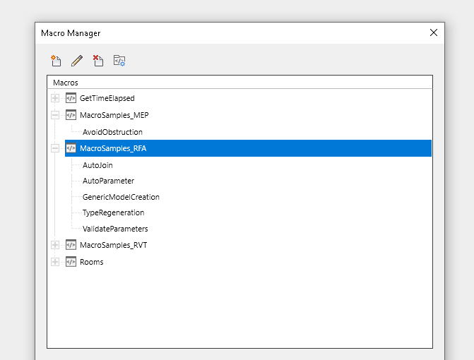
Figure 4: Revit Macro Family Samples

Folder “GetTimeElapsed”
This is a C# application-level module; it contains a macro named “GetTimeElapsedSinceLastSave. This sample demonstrates a possible situation of application-level macros to monitor the Revit session for certain events, such as document saving.

Please copy this folder into

%ALLUSERSPROFILE%\Autodesk\Revit\Macros\2025\
[Architecture|MEP|Structure|Revit]\AppHookup

And then run it in macro manager dialog box.

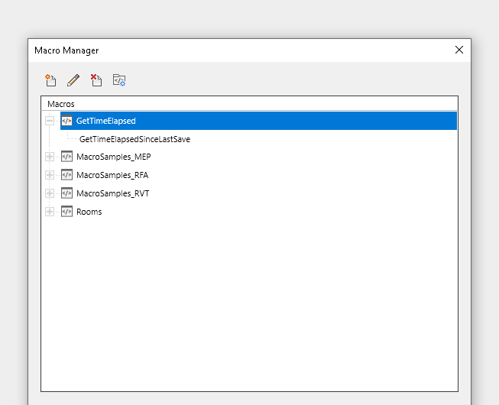
Figure 5: Application-level macro "GetTimeElapsedSinceLastSave" in C#

Folder “Rooms”
This is a C# application-level module. It includes application-level “GetAllRoomsInformation” macro. You can copy this folder into

%ALLUSERSPROFILE%\Autodesk\Revit\Macros\2025\
[Architecture|MEP|Structure|Revit]\AppHookup

And then run it in macro manager dialog box.

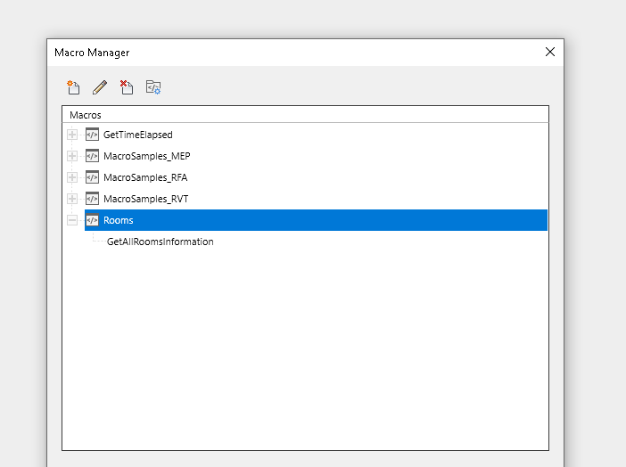
Figure 6: Application-level macro "Rooms" in C#

